Dijkstra’s Algorithm – three versions CLRS, 25.2

Input: Directed graph with non-negative edge weights and a source vertex
Output: tree that gives a shortest path from source to each vertex

Similar to Prim’s MST:

S = vertices whose shortest path is known (initially just the source)

Length of path
Predecessor (vertex) on path (AKA shortest path tree)

T = vertices whose shortest path is not known

Each phase moves a T vertex to S by virtue of that vertex having the shortest path among all T vertices.

Third version may be viewed as being BFS with the FIFO queue replaced by a priority queue.

1. “Memoryless” – Only saves shortest path tree and current partition. (dijkstraMemoryless.c)

Place desired source vertex x ∈ V in S
T = V – {x}
x.distance = 0
x.pred = (-1)
while T ≠ ∅
Find the edge (s, t) over all t ∈ T and all s ∈ S with minimum value for s.distance + weight(s, t)
(i.e. scan adj. list for each s)
t.distance = s.distance + weight(s, t)
t.pred = s
T = T – {t}
S = S ∪ {t}

Since no substantial data structures are used, this takes 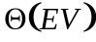 time.

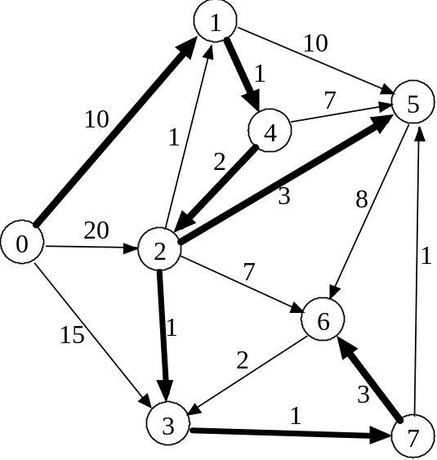

0 1 2 3 4 5 6 7
0(-) ∞ ∞ ∞ ∞ ∞ ∞ ∞
* 10(0) 20(0) 15(0)
* 11(1) 20(1)
13(4) * 18(4)
* 14(2) 16(2) 20(2)
* 15(3)
18(7) *
*
*

2. Maintains T-table that provides the predecessor vertex in S for each vertex t ∈ T to give the shortest possible path through S to t. (dijkstraTable.c)

Eliminates scanning all S adjacency lists in every phase, but still scans the list of the last vertex moved from T to S.

Place desired source vertex x ∈ V in S
T = V – {x}
x.distance = 0
x.pred = (-1)
for each t ∈ T
Initialize t.distance with weight of (x, t) (or ∞ if non-existent) and t.pred = x
while T ≠ ∅
Scan T entries to find vertex t with minimum value for t.distance
T = T – {t}
S = S ∪ {t}
for each vertex x in adjacency list of t (i.e. (t, x))
if x ∈ T and t.distance + weight(t, x) < x.distance
x.distance = t.distance + weight(t, x)
x.pred = t
Analysis:

Initializing the T-table takes Θ(V).
Scans of T-table entries contribute Θ(V²).
Traversals of adjacency lists contribute Θ(E).
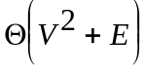 overall worst-case.

3. Replace T-table by a heap. (dijkstraHeap.cpp, minHeap.cpp)

The time for updating distances and predecessors increases, but the time for selection of the next vertex to move from T to S improves.

Place desired source vertex x ∈ V in S
T = V – {x}
x.distance = 0
x.pred = (-1)
for each t ∈ T
Initialize T-heap with weight (as the priority) of (x, t) (or ∞ if non-existent) and t.pred = x
Build-Min-Heap(T-heap)
while T ≠ ∅
Use Heap-Extract-Min to obtain T-heap entry with minimum t.distance
T = T – {t}
S = S ∪ {t}
for each vertex x in adjacency list of t (i.e. (t, x))
if x ∈ T and t.distance + weight(t, x) < x.distance
x.distance = t.distance + weight(t, x)
x.pred = t
Min-Heap-Decrease-Key(T-heap)

Analysis:

Initializing the T-heap takes Θ(V).
Total cost for Heap-Extract-Mins is Θ(V log V).
Traversals of adjacency lists and Min-Heap-Decrease-Keys contribute Θ(E log V).
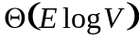 overall worst-case, since E > V.

Which version is the fastest?

Sparse 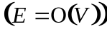 Dense 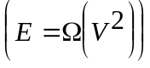

1. 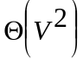 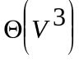
2.
3. 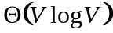 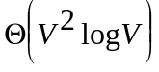

Question: Find the shortest path from s to v in the following graph using Dijkstra
‘s algorithm. (Intermediate steps are required. The backtracking for finding the shortest path is required.) (Lecture 4)

1
1
3
1
s
1
2
2
1
1
1
6
3
5
v
Answer: Using Dijkstra’s algorithm

Step 1: Initialization

1
1
3
1
0
s
∞
1
2
2
1
1
1
6
3
5
v
∞
∞
∞
∞
∞
∞
∞

Step 2: S={s}
1
1
3
1
0
s
1/s
1
2
2
1
1
1
6
3
5
v
∞
∞
∞
∞
∞
2/s
2/s
a

Step 3: S = {s} U{a} ={s,a}

1
1
3
1
0
s
1/s
1
2
2
1
1
1
6
3
5
v
2/a
∞
∞
∞
∞
2/s
2/s
a
b

Step 4: S = {s, a } U{b}

1
1
3
1
0
s
1/s
1
2
2
1
1
1
6
3
5
v
2/a
∞
∞
∞
5/b
2/s
2/s
a
b
Step 5: S = {s, a, b} U {c}
1
1
3
1
0
s
1/s
1
2
2
1
1
1
6
3
5
v
2/a
3/c
3/c
∞
5/b
2/s
2/s
a
b
c
d

Step 6: S ={s, a, b, c} U {d}
1
1
3
1
0
s
1/s
1
2
2
1
1
1
6
3
5
v
2/a
3/c
3/c
∞
5/b
2/s
2/s
a
b
c
d

Step 7: S ={s, a, b, c, d} U {e}
1
1
3
1
0
s
1/s
1
2
2
1
1
1
6
3
5
v
2/a
3/c
3/c
∞
5/b
2/s
2/s
a
b
c
d
e
Step 8: S = {s, a, b,c,d,e} U {f}

1
1
3
1
0
s
1/s
1
2
2
1
1
1
6
3
5
v
2/a
3/c
3/c
9/f
5/b
2/s
2/s
a
b
c
d
e
f

Step 9: S = {s, a, b,c,d,e,f} U{v}
1
1
3
1
0
s
1/s
1
2
2
1
1
1
6
3
5
v
2/a
3/c
3/c
9/f
5/b
2/s
2/s
a
b
c
d
e
f

Backtracking from v → b → a → s. Therefore, the shortest path from s to v is s→a→b→v. The length is 5.

